Volumetric flask
# Source: AI Source: Provided by: [Data Path: Persons Table -> ID Column: 1, Name_En Column: Motasem Essam] -> From: [ChatGPT] on [7/17/2026]
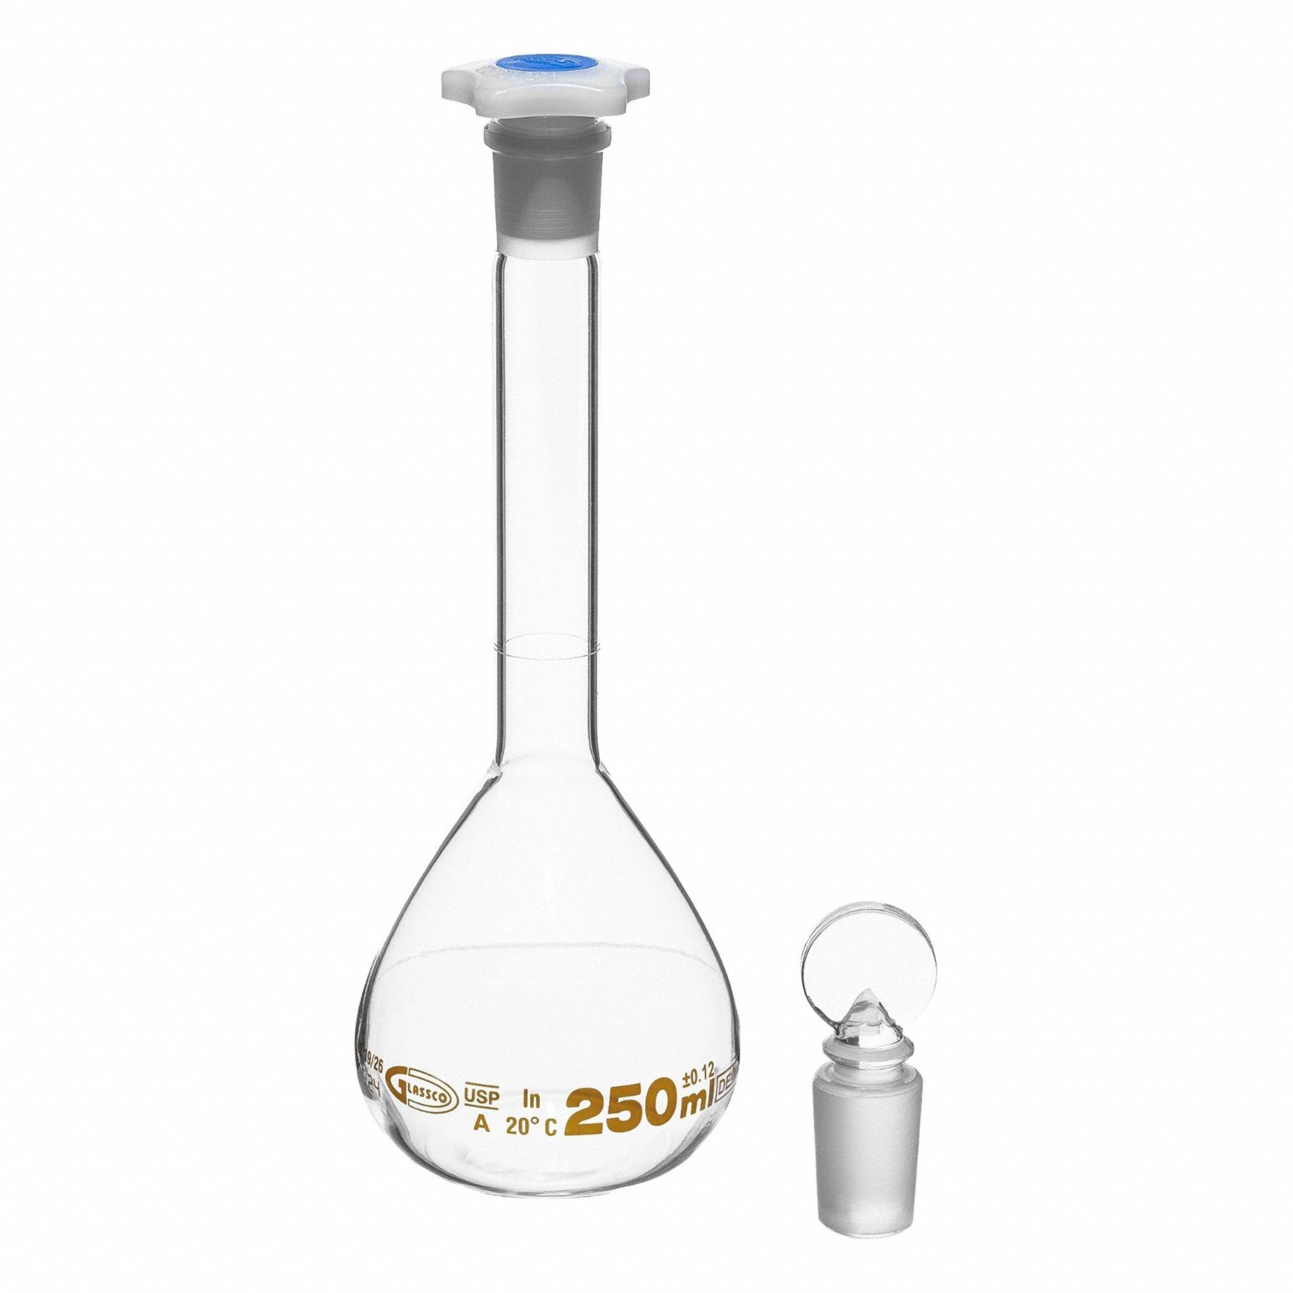
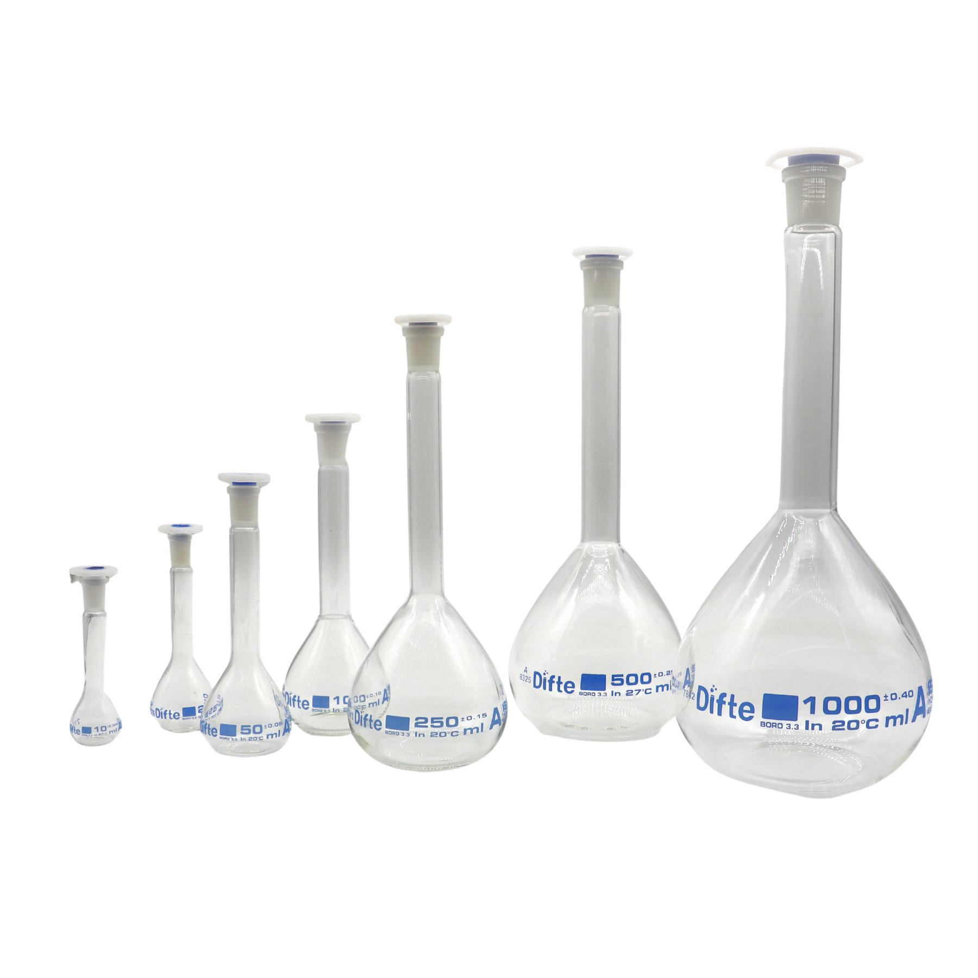
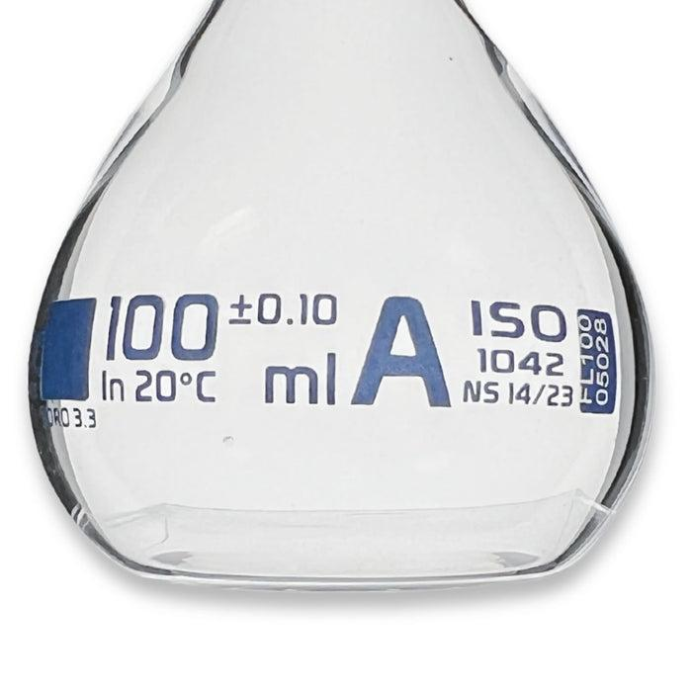
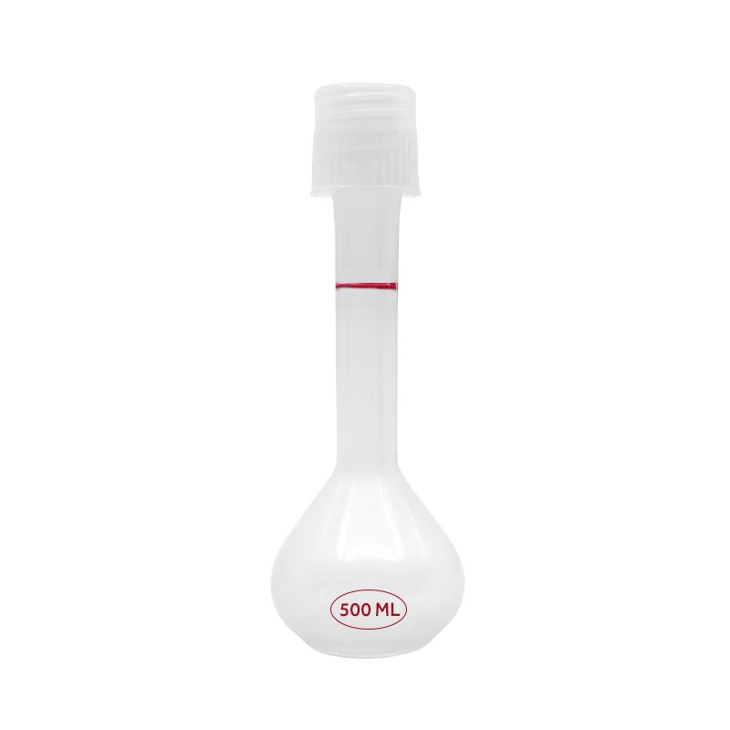
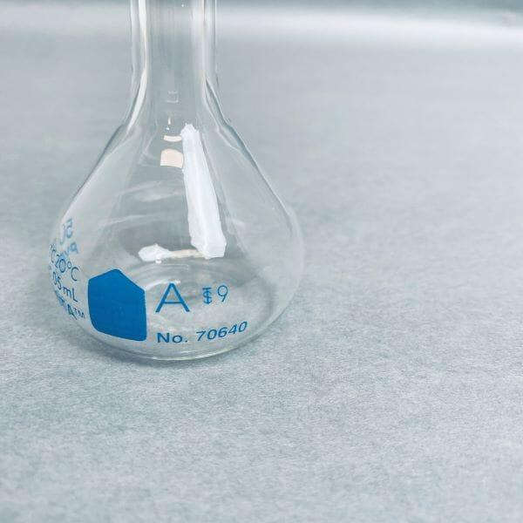
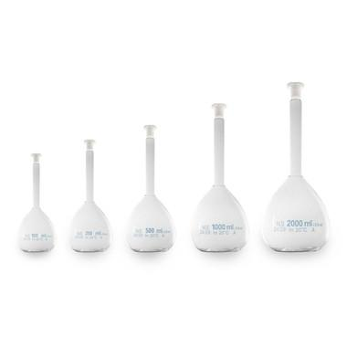
A Volumetric Flask is a high-precision laboratory volume-measuring instrument designed to prepare and contain one exact volume of liquid. Unlike a graduated cylinder or beaker, a volumetric flask is calibrated to a single volume, making it one of the most accurate pieces of volumetric glassware.
Volumetric flasks are widely used in chemistry, biology, pharmaceuticals, environmental science, food analysis, biotechnology, and research laboratories for preparing standard solutions and making precise dilutions.

Definition
# Source: AI Source: Provided by: [Data Path: Persons Table -> ID Column: 1, Name_En Column: Motasem Essam] -> From: [ChatGPT] on [7/17/2026]
A Volumetric Flask is a precision laboratory flask with a single calibration mark, designed to contain one exact volume of liquid at a specified temperature.

Purpose
# Source: AI Source: Provided by: [Data Path: Persons Table -> ID Column: 1, Name_En Column: Motasem Essam] -> From: [ChatGPT] on [7/17/2026]
A volumetric flask is used to:
- Prepare standard solutions.
- Prepare solutions of known concentration.
- Perform accurate dilutions.
- Measure one precise liquid volume.
- Prepare calibration standards.
- Analytical chemistry experiments.

Principle of Operation
# Source: AI Source: Provided by: [Data Path: Persons Table -> ID Column: 1, Name_En Column: Motasem Essam] -> From: [ChatGPT] on [7/17/2026]
A volumetric flask is calibrated so that when the bottom of the liquid meniscus touches the calibration mark, the flask contains its stated volume (for example, 250 mL) at the calibration temperature, commonly 20°C.

Main Components
# Source: AI Source: Provided by: [Data Path: Persons Table -> ID Column: 1, Name_En Column: Motasem Essam] -> From: [ChatGPT] on [7/17/2026]
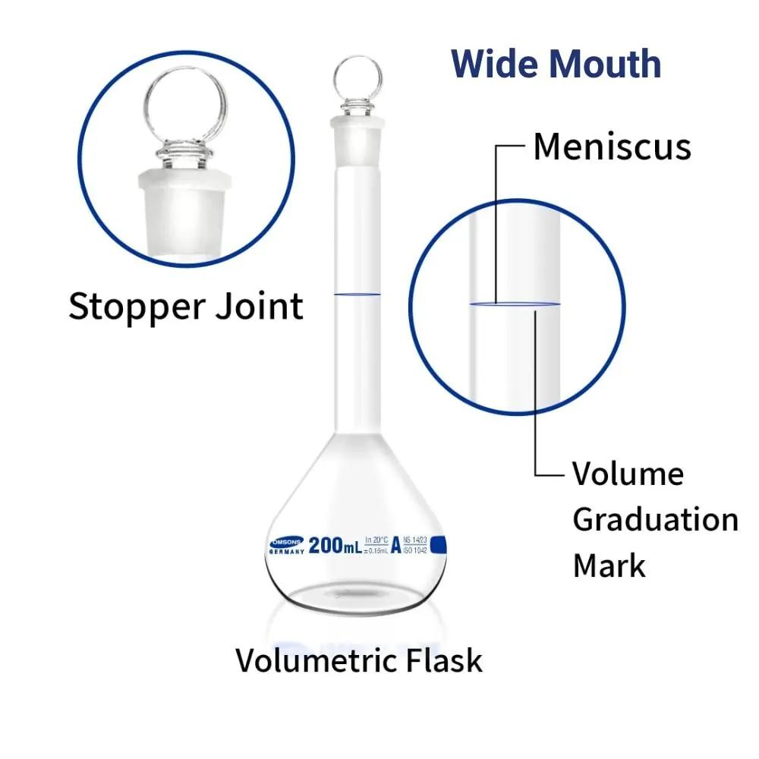
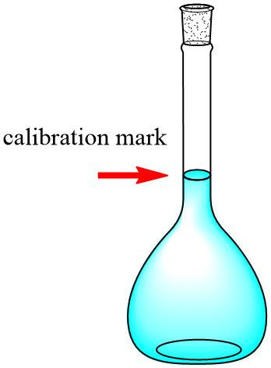
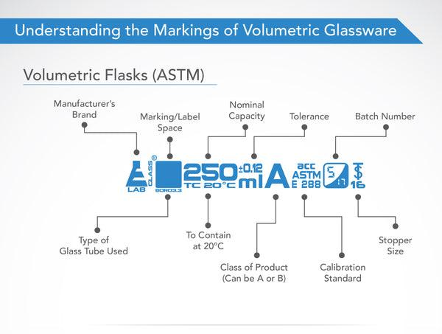
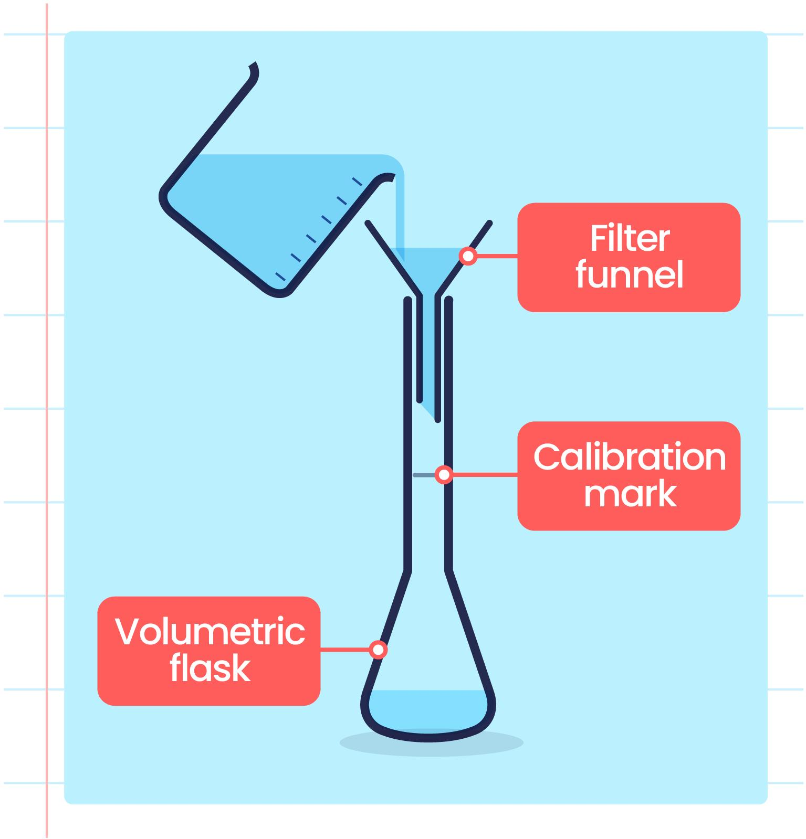
A typical volumetric flask consists of:
- Bulb-shaped body
- Long narrow neck
- Single calibration mark
- Stopper (glass or plastic)
- Flat base (on many modern designs)

Types of Volumetric Flasks

1. Glass Volumetric Flask
# Source: AI Source: Provided by: [Data Path: Persons Table -> ID Column: 1, Name_En Column: Motasem Essam] -> From: [ChatGPT] on [7/17/2026]
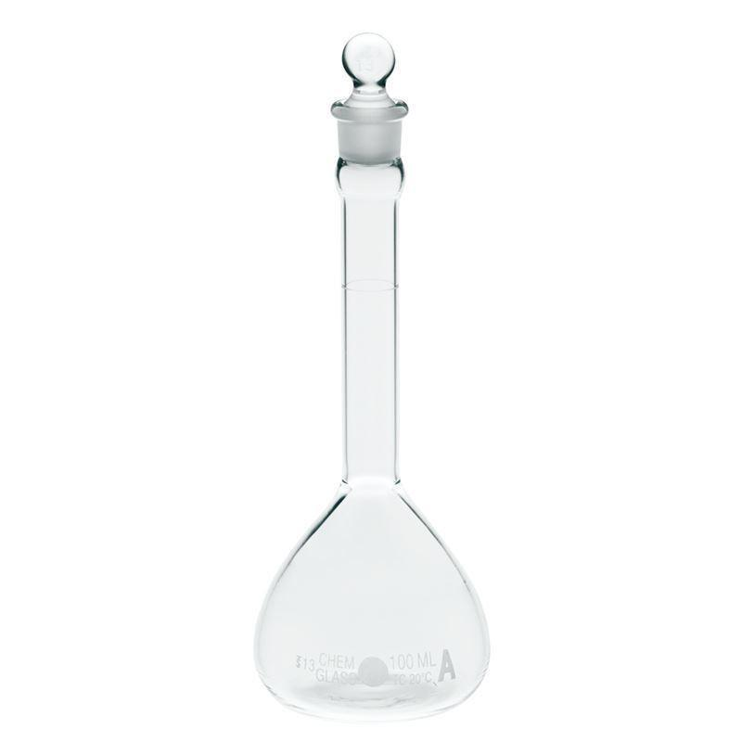
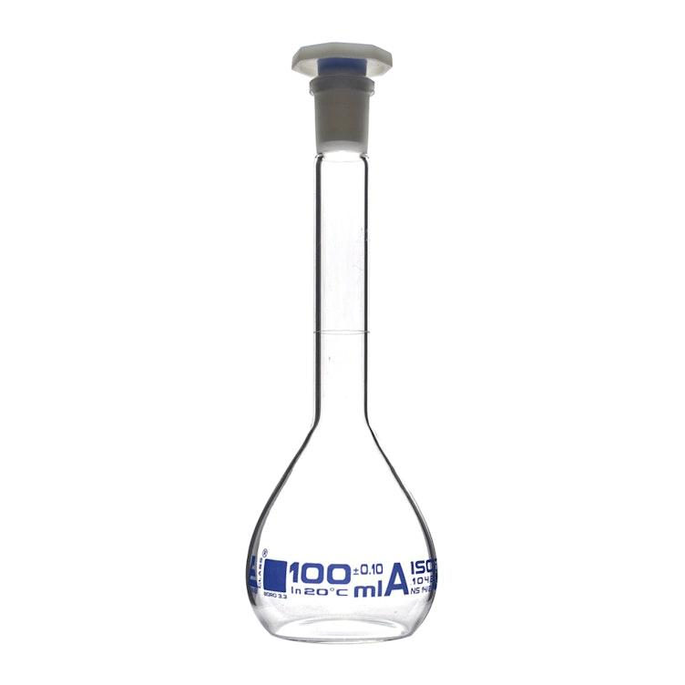
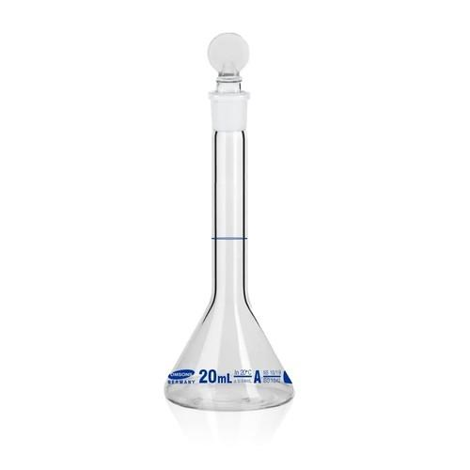
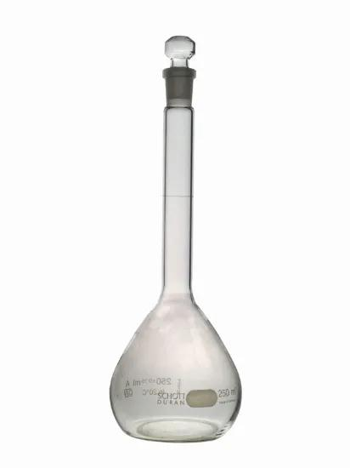
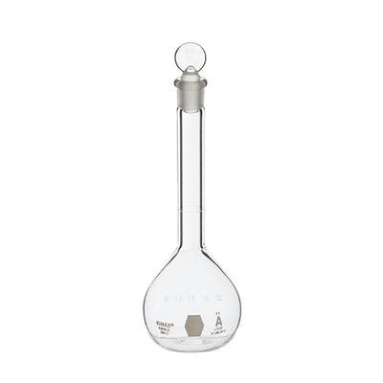
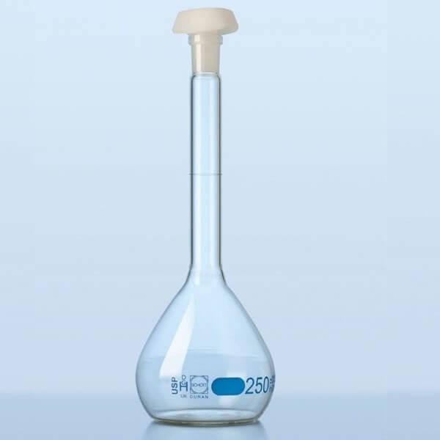
Description
Manufactured from borosilicate glass for excellent chemical and thermal resistance.
Features
- High accuracy
- Transparent
- Chemically resistant
- Heat resistant (not for direct heating)
Applications
- Analytical chemistry
- Pharmaceutical laboratories
- Research

2. Plastic Volumetric Flask
# Source: AI Source: Provided by: [Data Path: Persons Table -> ID Column: 1, Name_En Column: Motasem Essam] -> From: [ChatGPT] on [7/17/2026]
Description
Made from polypropylene or polyethylene.
Features
- Lightweight
- Break resistant
- Suitable for many aqueous solutions
Applications
- Educational laboratories
- Field laboratories
- Routine laboratory work

3. Class A Volumetric Flask
# Source: AI Source: Provided by: [Data Path: Persons Table -> ID Column: 1, Name_En Column: Motasem Essam] -> From: [ChatGPT] on [7/17/2026]

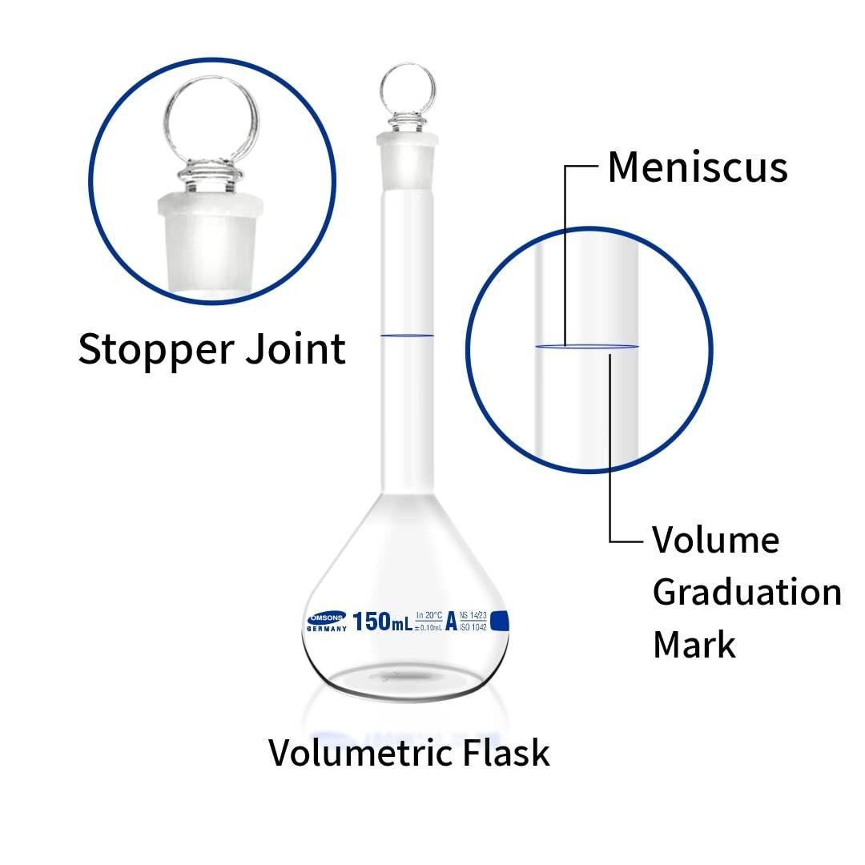
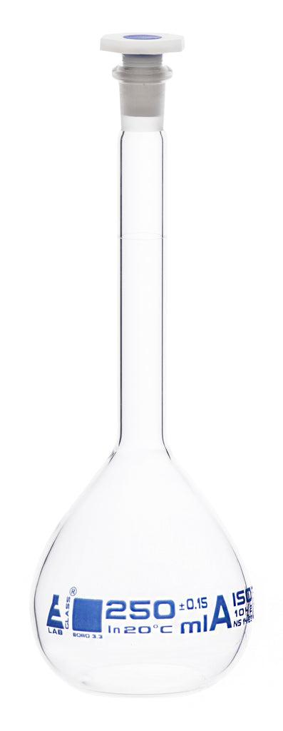
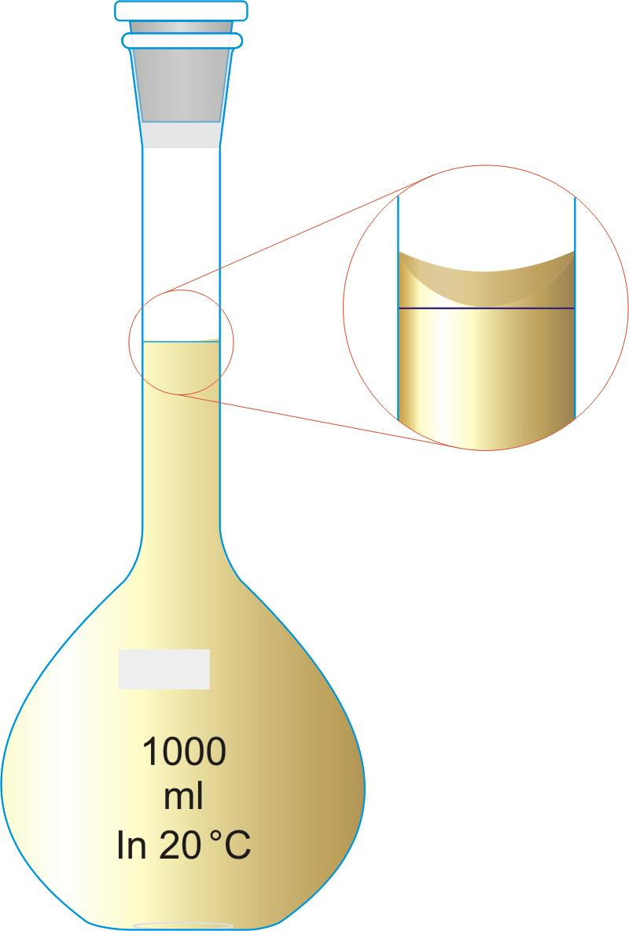
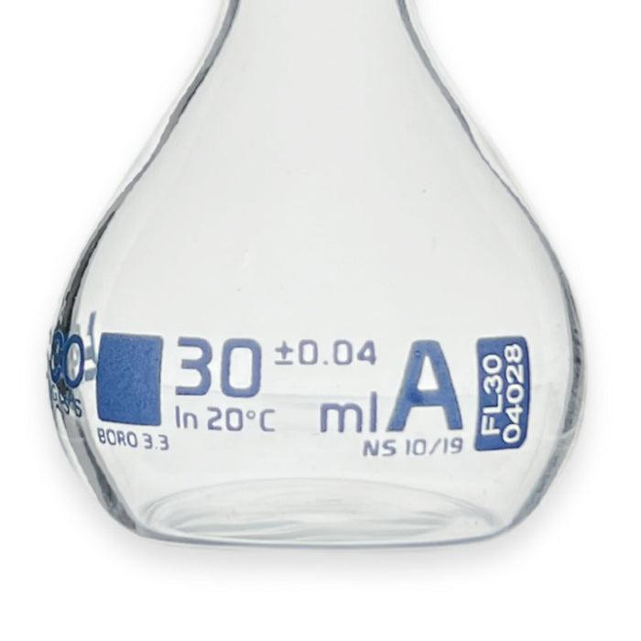
Description
Manufactured to the highest accuracy standards.
Features
- Tight manufacturing tolerances
- Certified accuracy
Applications
- Quantitative analysis
- Calibration
- Standard solution preparation

4. Class B Volumetric Flask
# Source: AI Source: Provided by: [Data Path: Persons Table -> ID Column: 1, Name_En Column: Motasem Essam] -> From: [ChatGPT] on [7/17/2026]
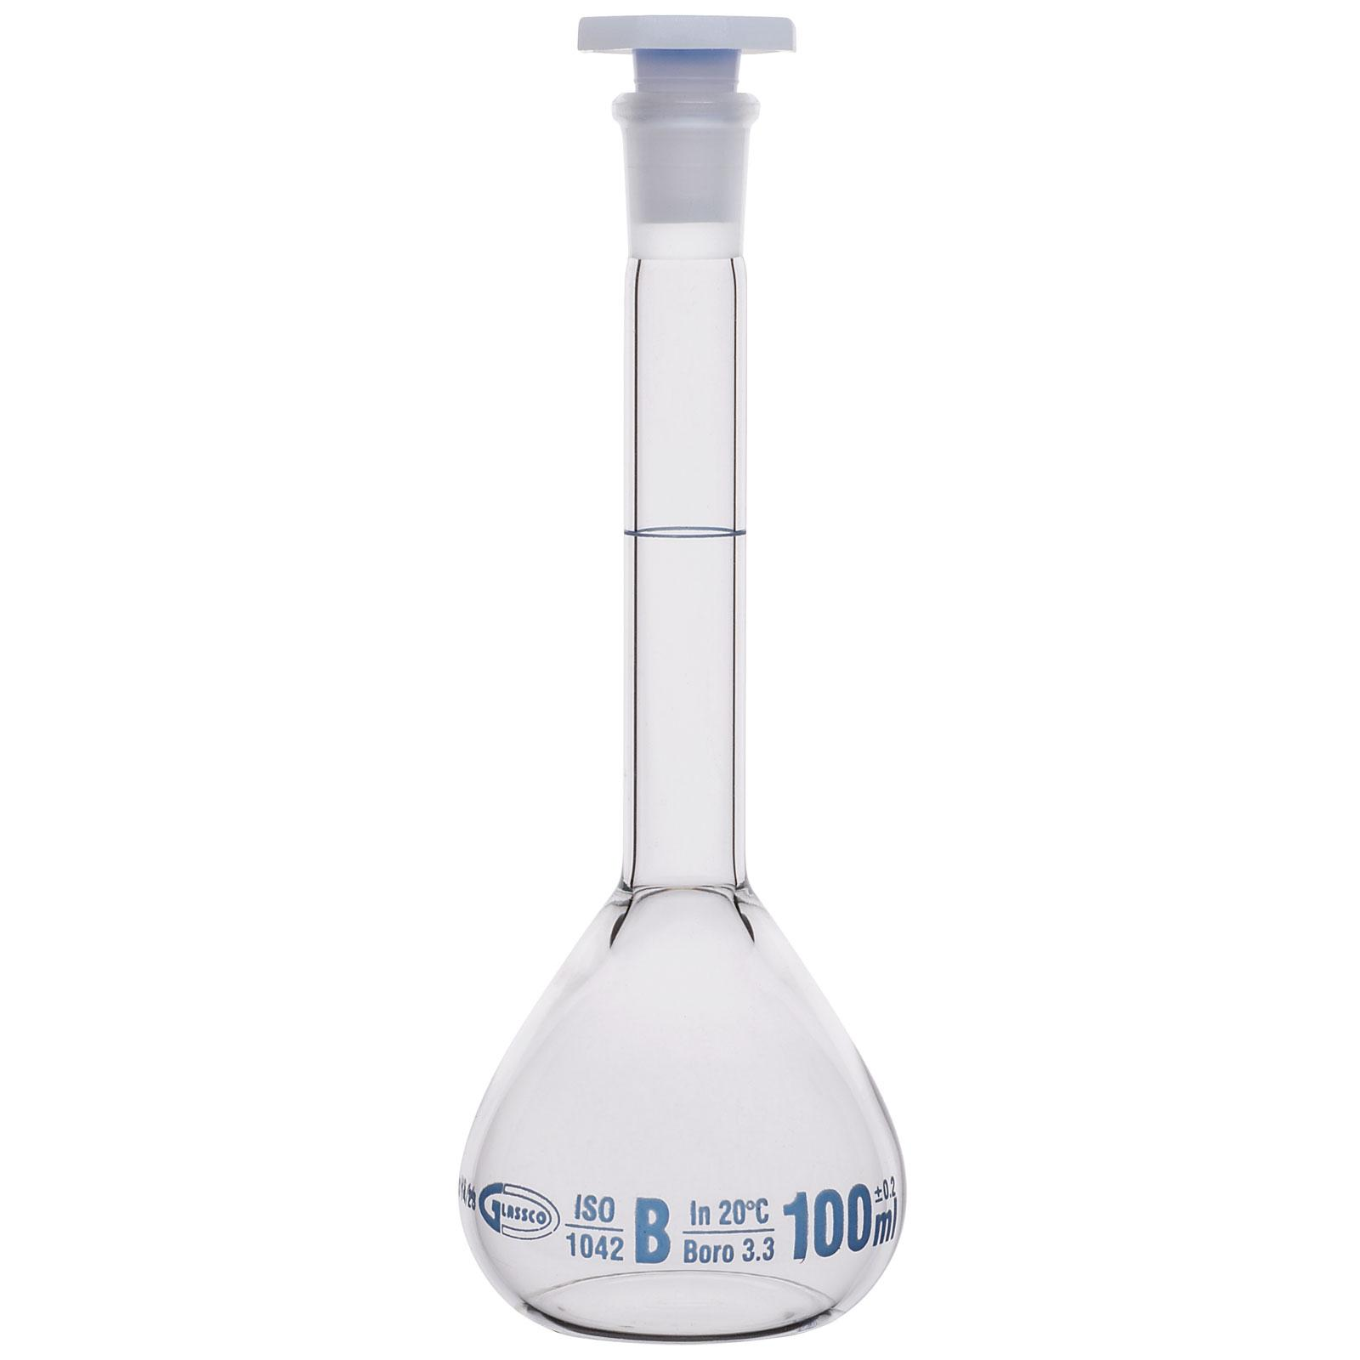
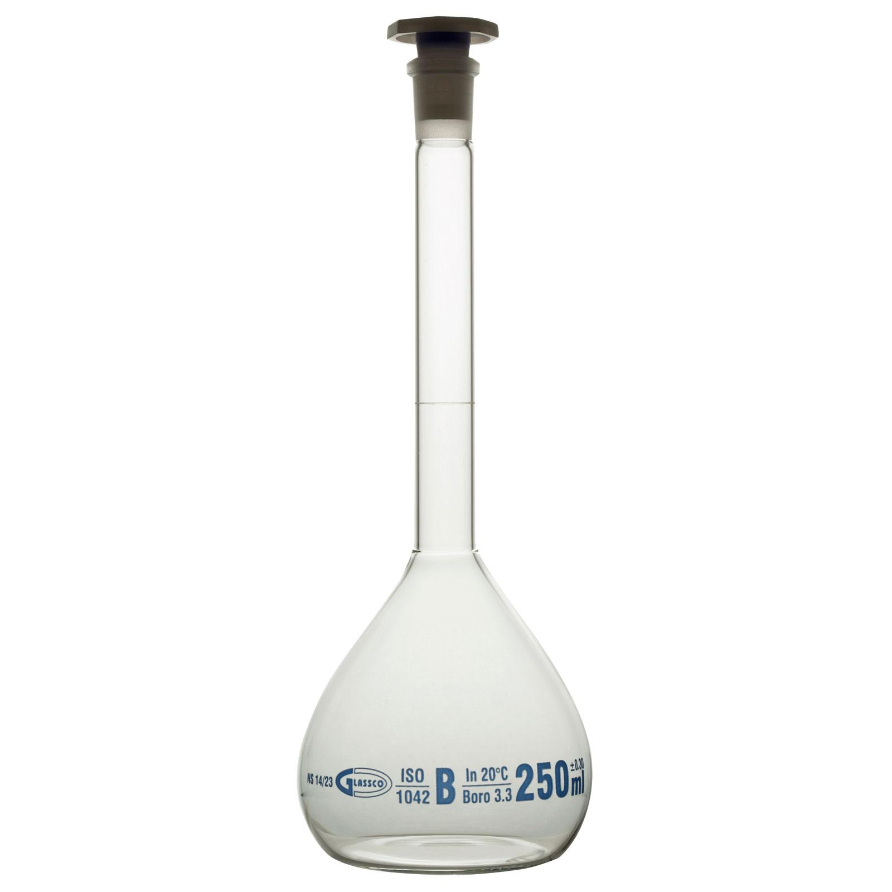
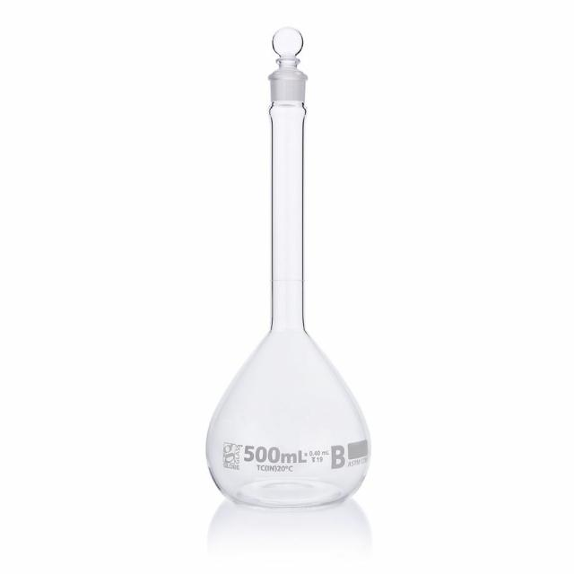
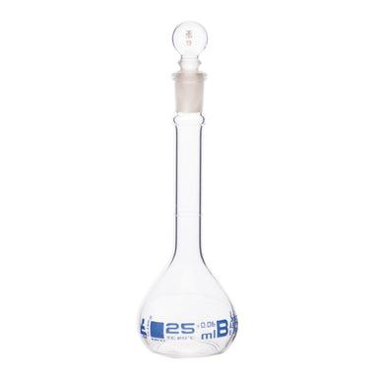
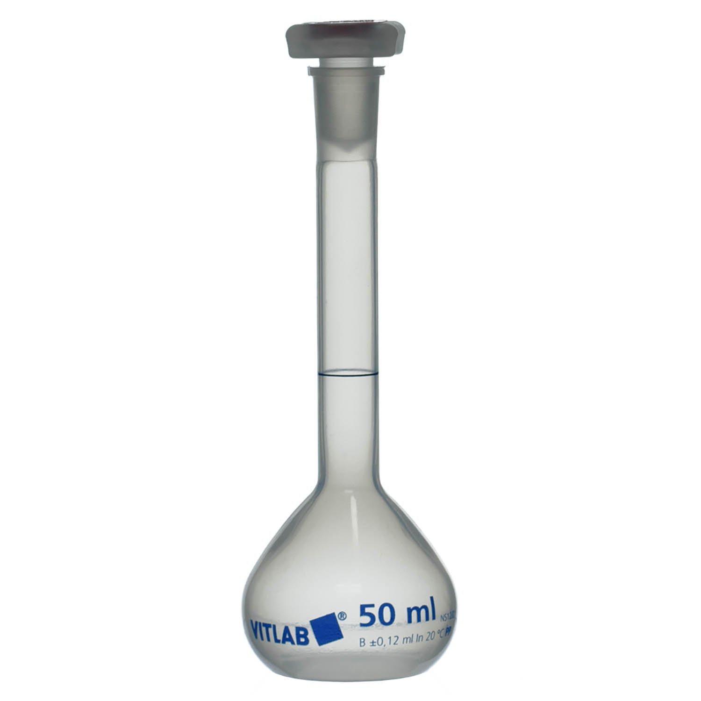
Description
Less accurate than Class A but suitable for general laboratory work.
Applications
- Education
- General solution preparation

Common Materials
# Source: AI Source: Provided by: [Data Path: Persons Table -> ID Column: 1, Name_En Column: Motasem Essam] -> From: [ChatGPT] on [7/17/2026]
Volumetric flasks are commonly made from:
- Borosilicate glass
- Polypropylene (PP)
- Polyethylene (PE)

Common Capacities
# Source: AI Source: Provided by: [Data Path: Persons Table -> ID Column: 1, Name_En Column: Motasem Essam] -> From: [ChatGPT] on [7/17/2026]
Typical capacities include:
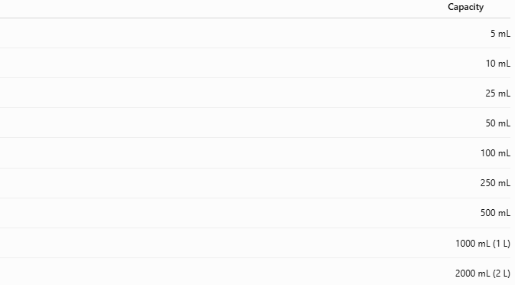
Capacity
5 mL
10 mL
25 mL
50 mL
100 mL
250 mL
500 mL
1000 mL (1 L)
2000 mL (2 L)

Measuring Units
# Source: AI Source: Provided by: [Data Path: Persons Table -> ID Column: 1, Name_En Column: Motasem Essam] -> From: [ChatGPT] on [7/17/2026]
Volumetric flasks are marked in:
- Milliliters (mL)
- Liters (L)

Resolution
# Source: AI Source: Provided by: [Data Path: Persons Table -> ID Column: 1, Name_En Column: Motasem Essam] -> From: [ChatGPT] on [7/17/2026]
A volumetric flask does not have multiple graduations.
Instead, it has:
- One calibration mark representing one exact volume.

Accuracy
# Source: AI Source: Provided by: [Data Path: Persons Table -> ID Column: 1, Name_En Column: Motasem Essam] -> From: [ChatGPT] on [7/17/2026]
Typical accuracy:
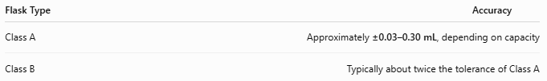
Flask Type | Accuracy
Class A | Approximately ±0.03–0.30 mL, depending on capacity
Class B | Typically about twice the tolerance of Class A

Measuring Range
# Source: AI Source: Provided by: [Data Path: Persons Table -> ID Column: 1, Name_En Column: Motasem Essam] -> From: [ChatGPT] on [7/17/2026]
Each volumetric flask measures only one fixed volume.
Examples:
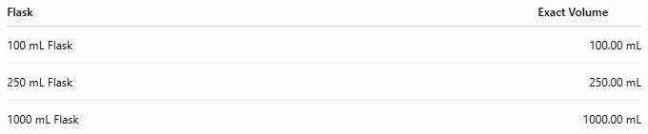
Flask | Exact Volume
100 mL Flask | 100.00 mL
250 mL Flask | 250.00 mL
1000 mL Flask | 1000.00 mL

How to Use a Volumetric Flask
# Source: AI Source: Provided by: [Data Path: Persons Table -> ID Column: 1, Name_En Column: Motasem Essam] -> From: [ChatGPT] on [7/17/2026]
- Add the required solute.
- Add solvent until the flask is about 80–90% full.
- Swirl until the solute dissolves completely.
- Carefully add solvent until the bottom of the meniscus reaches the calibration mark.
- Insert the stopper.
- Invert the flask several times to mix thoroughly.

Example
# Source: AI Source: Provided by: [Data Path: Persons Table -> ID Column: 1, Name_En Column: Motasem Essam] -> From: [ChatGPT] on [7/17/2026]
A 250 mL volumetric flask is filled until the meniscus reaches the calibration mark.
Contained volume:
250.00 mL

Applications
# Source: AI Source: Provided by: [Data Path: Persons Table -> ID Column: 1, Name_En Column: Motasem Essam] -> From: [ChatGPT] on [7/17/2026]
Volumetric flasks are used in:
- Analytical chemistry
- Pharmaceutical laboratories
- Environmental laboratories
- Water analysis
- Food testing
- Research
- Clinical laboratories
- Educational laboratories

Sources of Error
# Source: AI Source: Provided by: [Data Path: Persons Table -> ID Column: 1, Name_En Column: Motasem Essam] -> From: [ChatGPT] on [7/17/2026]
Instrument Errors
- Calibration defects
- Damaged neck
- Worn calibration mark

User Errors
- Reading the meniscus incorrectly
- Filling above the calibration mark
- Using the wrong temperature
- Incomplete mixing
- Incomplete dissolution of the solute before final filling

Environmental Errors
- Temperature changes
- Evaporation of volatile solvents
- Contamination

Advantages
# Source: AI Source: Provided by: [Data Path: Persons Table -> ID Column: 1, Name_En Column: Motasem Essam] -> From: [ChatGPT] on [7/17/2026]
A volumetric flask:
- Provides extremely accurate volume.
- Produces highly reproducible results.
- Is ideal for preparing standard solutions.
- Is simple to use.
- Minimizes measurement uncertainty.

Limitations
# Source: AI Source: Provided by: [Data Path: Persons Table -> ID Column: 1, Name_En Column: Motasem Essam] -> From: [ChatGPT] on [7/17/2026]
A volumetric flask:
- Measures only one fixed volume.
- Cannot be used for multiple volume measurements.
- Should not be heated directly.
- Glass versions are fragile.

Comparison with Other Volume Measuring Instruments
# Source: AI Source: Provided by: [Data Path: Persons Table -> ID Column: 1, Name_En Column: Motasem Essam] -> From: [ChatGPT] on [7/17/2026]
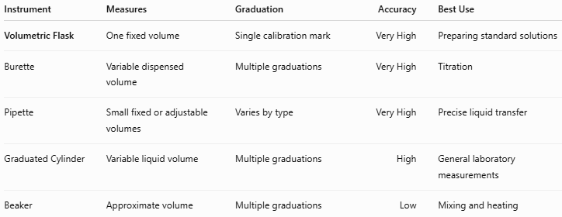
Instrument | Measures | Graduation | Accuracy | Best Use
Volumetric Flask | One fixed volume | Single calibration mark | Very High | Preparing standard solutions
Burette | Variable dispensed volume | Multiple graduations | Very High | Titration
Pipette | Small fixed or adjustable volumes | Varies by type | Very High | Precise liquid transfer
Graduated Cylinder | Variable liquid volume | Multiple graduations | High | General laboratory measurements
Beaker | Approximate volume | Multiple graduations | Low | Mixing and heating

Care and Maintenance
# Source: AI Source: Provided by: [Data Path: Persons Table -> ID Column: 1, Name_En Column: Motasem Essam] -> From: [ChatGPT] on [7/17/2026]
To maintain accuracy:
- Wash thoroughly after use.
- Avoid scratching the calibration mark.
- Store with the stopper removed when drying.
- Handle glass carefully to prevent cracks.
- Use only compatible cleaning agents.
- Verify calibration periodically in quality-controlled laboratories.

Common Mistakes
# Source: AI Source: Provided by: [Data Path: Persons Table -> ID Column: 1, Name_En Column: Motasem Essam] -> From: [ChatGPT] on [7/17/2026]
- Overfilling beyond the calibration mark.
- Reading the meniscus incorrectly.
- Preparing solutions before the solute is fully dissolved.
- Assuming the flask measures multiple volumes.
- Using the flask outside its calibration temperature without considering thermal expansion.

Key Points
# Source: AI Source: Provided by: [Data Path: Persons Table -> ID Column: 1, Name_En Column: Motasem Essam] -> From: [ChatGPT] on [7/17/2026]
- A Volumetric Flask measures one exact volume.
- Common types:
  - Glass Volumetric Flask
  - Plastic Volumetric Flask
  - Class A
  - Class B
- Typical capacities:
  - 5 mL to 2000 mL
- Used primarily for:
  - Standard solution preparation
  - Accurate dilutions
  - Analytical chemistry
- It is one of the most accurate laboratory volume-measuring instruments.

Conclusion
# Source: AI Source: Provided by: [Data Path: Persons Table -> ID Column: 1, Name_En Column: Motasem Essam] -> From: [ChatGPT] on [7/17/2026]
A Volumetric Flask is a precision laboratory instrument specifically designed to contain one exact volume of liquid with exceptional accuracy. Its distinctive bulb-shaped body, narrow neck, and single calibration mark make it the preferred choice for preparing standard solutions and performing accurate dilutions. Because of its high precision and reproducibility, the volumetric flask is an indispensable tool in analytical chemistry, pharmaceutical laboratories, environmental testing, research, and quality control, where accurate solution preparation is essential.

